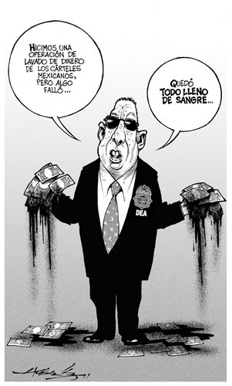

Jakub Čeněk:

This cartones reacts to the DEA announcement[1] that this agency was conducting clandestine money laundering operations against Mexico’s most powerful cartels in order to reveal mechanisms and people involved in it However, this announcement raise a serious debate about appropriateness of these operations which are damaging Mexican sovereignty. Although the DEA publicly claimed that it is collaborating with Mexican authorities on these operations. In addition, borders to reveal crime and on other hand to contribute on it are very thin.

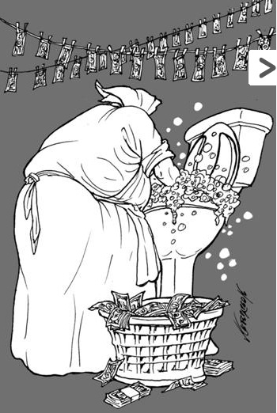

This cartones follows up with the first one and reacts on the DEA money laundering operations in Mexico.[2]

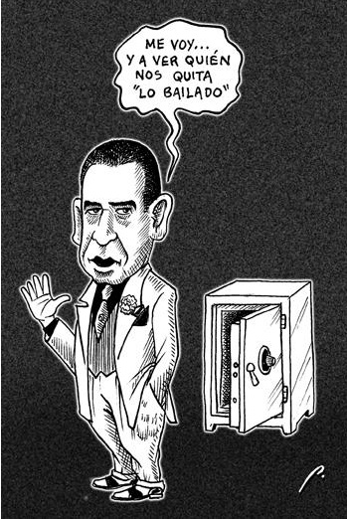

*"I'm going ... and see who takes away" We Danced."*

Humberto Moreira Valdés is the man on the picture, former president of PRI (until 2.12.2011) and governor of Coahuila. During his term he managed to burden his state with debts; 23x from 300 million pesos to 7.600 million pesos. Standard and Poor changed the rating of Coahuila from A+ to BBB-, six levels decline.[3]

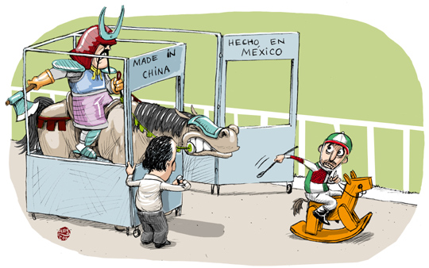

The removal of "transitional measures" on import fees which were applied to specific goods (204 products; including footwear, apparel, toys...) imported from China. *„In 2007, U.S. exports of the listed products led to the Mexican market totaled $ 860 million, but the amount was reduced to 662 in 2010, while those from China jumped from 376 million to $ 635 million in the same time.“* In other words, China registered a huge increase in export trade with Mexico. Therefore, Mexican companies will face a tougher competition from Chinese import.[4]

# Analysis of the newsletter based on political cartoons

Petr Šrámek

Government and Politics in Mexico - JMM591

ZS 2011/2012

All four of the political cartoons I will comment upon in the following paper are from the Mexican newspaper La Jornada, from October 5-10 releases. The first of the three so-called “cartones” is related to "electronic crime-sharing", a relatively new phenomenon reflecting two major developments in Mexican society: the rise of drug-related violence and the rise of on-line social networks. In other words: Mexico is becoming highly connected and highly dangerous at the same time: Around 40,000 people have been killed in the drug war over the past five years, while the middle class is growing, scared and increasingly networked. There are 30 million regular internet users in Mexico, out of which 95 percent have profiles on Facebook and 4 million have a Twitter account.

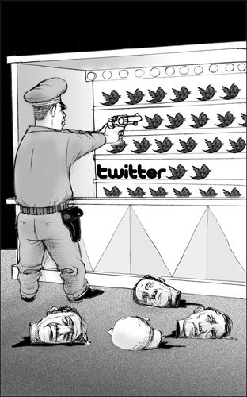Some interpret the spread of social media in Mexico as a symptom of institutional dysfunction, since the social networks proved to be a swift and valuable source of “survival information” for those Mexicans who want to remain safe. This was well demonstrated by the early-October Veracruz incident where gunmen held up traffic and dumped 35 bodies at rush hour. The police lacked any information about the incident, whereas rumours spread on Twitter well ahead of the event. However, Veracruz authorities had already targeted social networks with a restrictive law which punished anyone who would create unnecessary panic on social networks.

This law was passed as a reaction to recent false rumor that local schools were under terrorist attack, which caused traffic accidents as parents flooded the roads. This cartoon reflects the very notion that the authorities criminalize using Twitter for enhancing public and personal safety, while the root cause of the rumours, the violence symbolized by the cut-off heads lying on the ground, remained unresolved. Some experts also point out the danger of prosecuting well-intentioned watchdogs, given how chaotic the real-time spontaneous violence reporting can be.

The second cartoon is targeting the long-reigning and still well-established party PRI (Institutional Revolutionary Party - Partido Revolucionario Institucional) and its president Humberto Moreira Valdés. The writing can be translated to English as: “Since when is it a problem for us to have a tail there?” So as to understand the point correctly, it is crucial to be aware of the Mexican-Spanish idiom “to have a tail”, which means “to have serious consequences” or “to leave some mess behind”. This refers both to the controversial history of the “state party” PRI, as well as to Moreira’s serving as the current governor of Coahuila. The public debt of this Mexican state increased 100 times under his reign and he is still considering candidacy in the 2012 Mexican presidential election.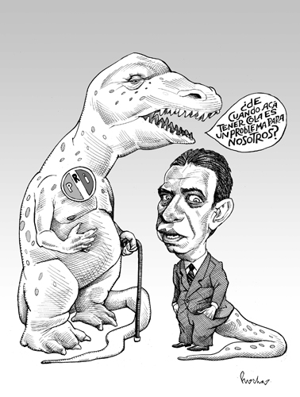

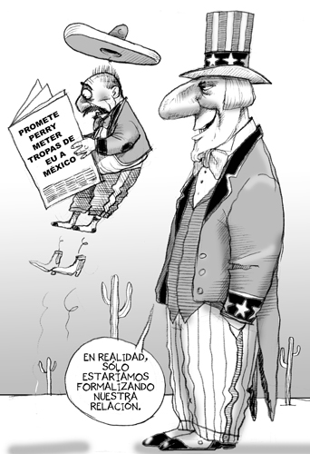The third and last cartoon depicts a stereotypical Mexican villager outraged at Texas Governor Rick Perry’s suggestion of sending U.S. troops to Mexico to solve the drug related problems, if he were elected president. This quote was considered extremely controversial since there is a widespread consensus that the drug war is closely linked to U.S. drug and weapon market, and the historical legacy of 1848-50 Mexican-American War. The current Mexican president Felipe Calderón protested against the statement, arguing that the U.S. should start at home and reduce its demand for drugs and shipment of guns. The character depicting “Uncle Sam” plainly remarks that the military presence of the U.S. would be a mere “formalization” of the current mutual relations.

**„Cartones“ (28 Nov – 04 Dec, 2011)**

**Tatiana Hořavová**

**1. The murder of a human rights activist Nepomuceno Moreno and its relation to Felipe Calderón**

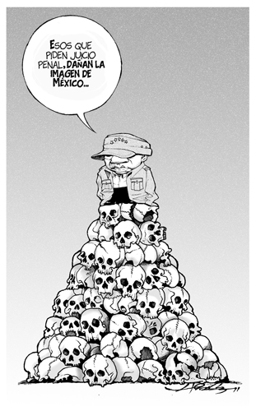

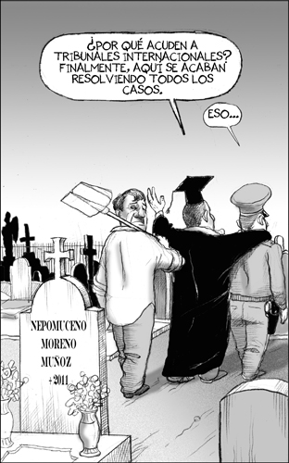 In the first cartoon (Picture 1), there is the current Mexican president Felipe Calderón, standing atop a pile of skulls, saying “Those who ask for criminal prosecution damage the image of Mexico.”

This is related to the fact that a group of Mexican human rights lawyers appealed to the International Criminal Court, because they think that Calderón´s offensives against drug cartels are crimes against humanity as a number of civilians died in the process.

Picture 1: “Bola de irresponsables”, 29/11/2011, La Jornada; Author: Hernández; Source: <http://www.jornada.unam.mx/2011/11/29/cartones/3>

Picture 2: „La cantaleta de los derechos humanos“, 30/11/2011; La Jornada, Author: Fisgón; Source: <http://www.jornada.unam.mx/2011/11/30/cartones/1>

Calderón condemned the claims and “is seeking legal action against the activists.“[5]

Mr Nepomuceno Moreno was one of such activists; the second cartoon (Picture 2) shows his grave and a priest (?) saying “Why [should anyone] go to international courts? After all, all cases are solved here all right”, which might be a reference back to Calderón´s unwillingness to accept the fact that human rights activists can appeal to an international court when they are unhappy about his actions.

**2. Christine Lagarde’s comments concerning the state of Mexican economy**

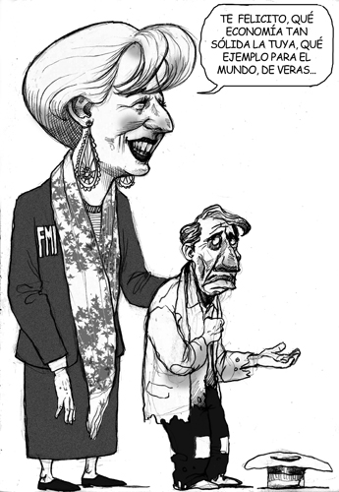

The cartoon shows the current IMF Managing Director Christine Lagarde as saying: “I congratulate you that your economy is so solid that it can really serve as an example for the entire world.” Her companion in the cartoon, a beggar, is probably supposed to be a common Mexican citizen.

This is related to the fact that Lagarde´s praise came hours after the release of a study by the Economic Commission for Latin America, which said that Mexico is one of the countries in the region with highest increases in poverty level.

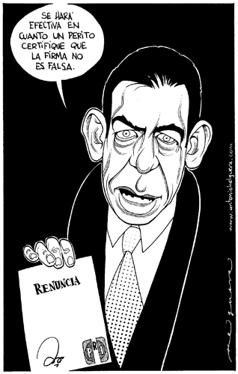 La Jornada therefore speculated whether Ms Lagarde was really in the dark concerning the real state of Mexican economy; rather, it sees it as “an exercise in public relations with the hosts”[6], or / also, as a way to conceal the fact that the current state of Mexico´s economy is influenced by “the application of economic guidelines enforced by the IMF.”[7]

Picture 3: „Ni la burla perdonan“, 02/12/2011, La Jornada; Author: Fisgón; Source: <http://www.jornada.unam.mx/2011/12/02/cartones/0>

**3. Humberto Moreira’s resignation as the PRI party president and its relation to Enrique Pena Nieto**

Picture 4: „Crea fama...“, 03/12/2011, La Jornada, Author: Helguera; Source: <http://www.jornada.unam.mx/2011/12/03/cartones/1>

Mr Moreira stepped down from the position of the PRI party president after lengthy public discussion concerning unexplained financial issues related to his previous post[8] (that of the governor of the Mexican state of Coahuila).

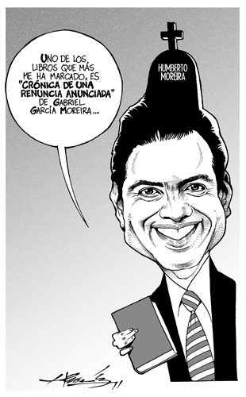 The first cartoon (Picture 4) shows Mr Moreira saying “The resignation will be valid when an expert certifies authenticity of the signature”; this refers to the alleged falsification of his signature by the Coahuila´s state treasurer in the past[9].

Mr Moreira´s resignation was probably motivated also by his attempt to “save” Mr Enrique Pena Nieto, the PRI presidential candidate, who is supposed to represent the “new PRI”, i.e. PRI without bribery, cronyism etc.

Picture 5 shows Mr Nieto saying “The book that most shaped me is *Chronicle of a resignation foretold* by Gabriel Garcia Moreira”. The book title is an allusion to Marquez´s “Chronicle of a Death Foretold”, which is a play on the fact that Mr Moreira has long been having problems defending his own position.

Also, Mr Nieto talking about “the books that shaped him” is a reference to major difficulties Mr Nieto experienced at the Guadalajara International Book Fair where he was asked to name three books that influenced him[10].

Picture 5: „Lector consumado“, 04/12/2011, La Jornada, Author: Hernández, Source: <http://www.jornada.unam.mx/2011/12/04/cartones/0>

**Sources**

* Justice in Mexico Project [online]. November 29, 2011 [cit. 2011-12-19]. Petition filed at International Criminal Court against Calderón, El Chapo. Retrieved from WWW: <http://justiceinmexico.org/2011/11/29/petition-filed-at-international-criminal-court-against-calderon-el-chapo/>.
* La Jornada [online]. December 01, 2011 [cit. 2011-12-19]. El despropósito de Lagarde. Retrieved from WWW: <http://www.jornada.unam.mx/2011/12/01/edito>.
* The Economist [online]. December 06, 2011 [cit. 2011-12-20]. Politicians and books: Well-read or red-faced?. Dostupné z WWW: <http://www.economist.com/blogs/prospero/2011/12/politicians-and-books>.
* WILKINSON, Tracy; SANCHEZ, Cecilia. Los Angeles Times [online]. November 29, 2011 [cit. 2011-12-19]. Mexican activist against violence is slain. Retrieved from WWW: <http://latimesblogs.latimes.com/world_now/2011/11/mexican-activist-against-violence-is-slain-.html>.
* ZABLUDOVSKI, Karla. Mexico: Party Official Resigns: The New York Times. December 3, 2011, [cit. 2011-12-21]. Retrieved from WWW: http://www.nytimes.com/2011/12/03/world/americas/mexico-humberto-moreira-party-official-resigns.html

**Government and Politics in Mexico**

**Cartones** – explanation Jaroslav Zukerstein

1) 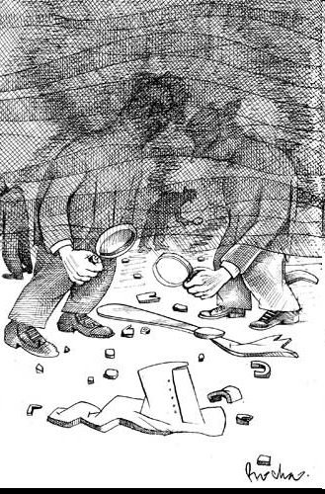

All cartones are from the week 14th to 20th November 2011 and appeared on La Jornada website. The first cartone is about Mexican Interior Minister Francisco Blake who was killed in a helicopter crash. President Felipe Calderón assumed that the accident happened due to bad weather conditions. However, this has not been the first mysterious accident of interior minister in Mexico - one of his predecessors, Juan Camilo Mourino, was killed in a plane crash in Mexico City three years ago. Francisco Blake Mora was appointed to the post last year and was a key figure in the war against drug cartels. The investigation is under way and according to the critics the fogy weather may not be the cause of the accident.

2)

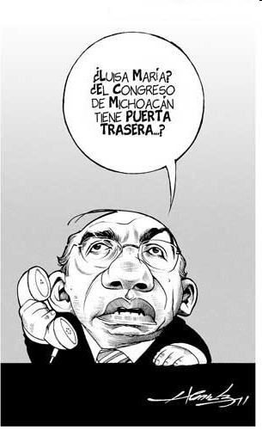

The elections last week to the governorship of Michoacán were very important to President Calderón. His sister was one of the candidates and many people viewed this election as a referendum on the governing PAN’s drug war, which President Calderón launched in 2006. He asks his sister Luisa María if there are back door – according to preliminary results released on Monday 14th November PAN is no longer a leader.

3)

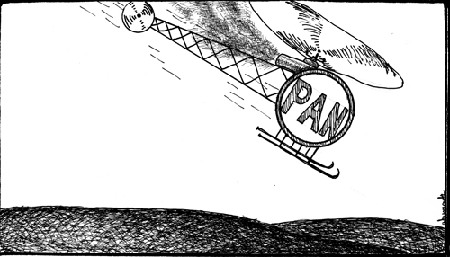

Finally, the support of PAN in Michoacán fell apart as the helicopter of Interior Minister few days before. Calderón’s sister, Luisa María, lost the gubernatorial election to PRI candidate Fausto Vallejo, who won 35 percent of the votes. PRI focused mainly on economic issues including poverty and migration. The fight against drug cartels which was the main topic of PAN candidate Luisa María Calderón did not motivate voter to get her into office. The third is the PRD which had held the governorship of Michoacán for the last 12 years.

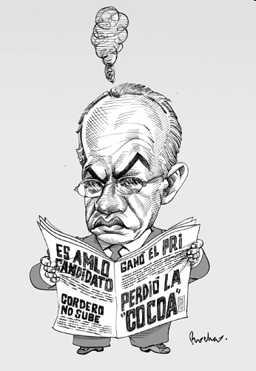4)

Mexican President Felipe Calderón was remarkably disappointed by the current situation - Perdió la “Cocoa” = Forget Luisa María Calderón. The second news which made him angry is the nomination of “AMLO” Andrez Manuel Lopez Obrador; he is the man who lost Mexico's last presidential election and will try again in the upcoming election in 2012 after winning an opinion poll released on Tuesday 15th November by the PRD.

5)

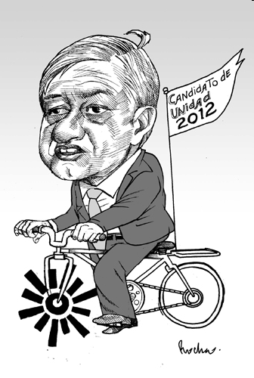

Former Mexico City mayor Andres Manuel Lopez Obrador will make another run for the presidency in 2012. In 2006, he was defeated by current President Felipe Calderón. However Lopez Obrador claimed the vote to be fraudulent and staged massive protests on Zocalo square. The poll asked 6,000 supporters of left-wing candidates whether they preferred him or Mexico City Mayor Marcelo Ebrard. Lopez Obrador narrowly won but he is also the only one who got negative votes. He is not a cup of tea for everyone.

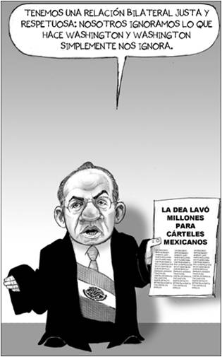Ladislav Sedlák:

I.

President Calderon

It relates to the issue of DEA laundering money for the Drug Cartels in Mexico, several DEA agents were accused of performing the criminal activity.

Approximate translation: We have a bilateral and respectful relationship with the US. We ignore what they do and they simply ignore us

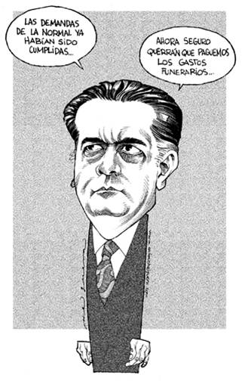II.

Alonso Lujambio- the current Secretary of Public Education

Referres to the incident when two high school students got killed in clashes with the police.

The students had asked state governor Angel Aguirre Rivero to fulfill a promise to increase their daily food subsidy from 10 pesos a day (approx. $0.70) to 50 pesos, and had agreed to meet with the governor to discuss this issue several times.

But frustrated by the governor’s inability to show up in four previously scheduled meetings, the students decided to stage a protest in the city, blocking the highway that connects the city, and much of central Mexico

Translation: all the petitions from the "normal" students etc... have been fulfilled now they will certainly want us to pay for the funerals as well....

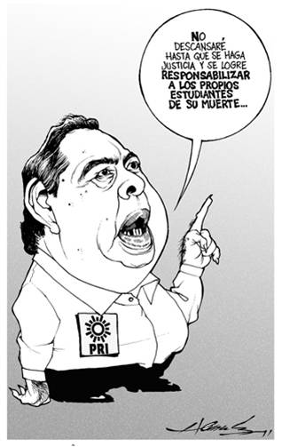

III.

Angel Rivero- the Guerrero state Governor

It speaks about the same issue as the second one.

Translation: I’ll take care of the justice and prove that the students were responsible for their own deaths

Olga Staňková, 1st Year, DAS

Government and Politics in Mexico

February 2012

**Cartones**

**1.** Felipe Calderón is contemporary president of Mexico, he comes from PAN (National Action Party). The cartoon reflects the longtime arrangement between governments controlled by PRI (Institutional Revolutionary Party), which lost the political power in 2000, when Vincente Fox from PAN was elected. He started what is now called the Mexican drug war. The actual president Felipe Calderón continues in this hard-line approach and cooperates with the United States agencies (especially DEA) while many civilians are dying on daily basis.

The Cartoon was published in the leftist newspapers, La Jornada, that criticize the current government quite often. This cartoon bitterly criticize the cooperation between president Calderón (PAN) and the Americans.

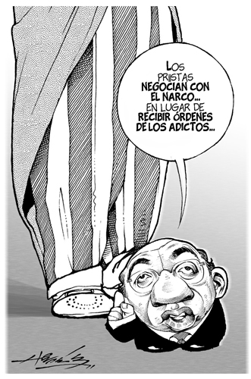

„PRI negotiates with the narcos while they should be taking orders of the addicts“

**2.** Enrique Pena Nieto is a presidential candidate of PRI for the election of 2012. He publicly declared that the Mexican oil is not administrated very well by the national oil monopoly PEMEX. Mexicans generally believe that the U.S. is stealing their oil in the Mexican Gulf. According to this cartoon, it would be maybe better if the Mexican oil was controlled by international companies, than by PEMEX. La Jornada newspapers show the conflict between the policy of PRD (Party of Democratic Revolution), the governing party PAN and the former leading party PRI - party of Pena Nieto. The possible opening of the oil industry to foreign investments is very discussed in Mexico.

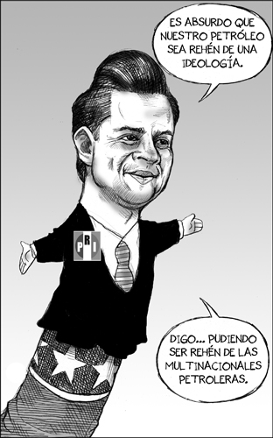„It’s absurd that our oil is a hostage of ideology.“

„I mean... It could be hostage of international oil companies.“

**3.** In order to reduce air pollution, there are time restrictions on driving in Mexico City and in certain regions of the country. The restrictions are based on license plate number and there is at least one day each week and one Saturday per month when driving is forbidden. These regulations are strictly enforced and apply equally to permanent, temporary and foreign plates.

Both cartoons are from the newspapers Excelsior, generally considered as centrist.

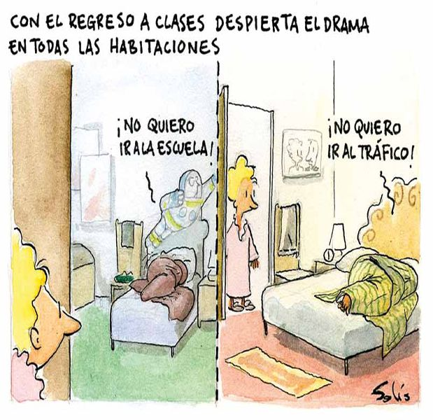„With the return to school, the drama starts in all homes“

„I don’t want to go to school!“

„I don’t want to go to traffic!“

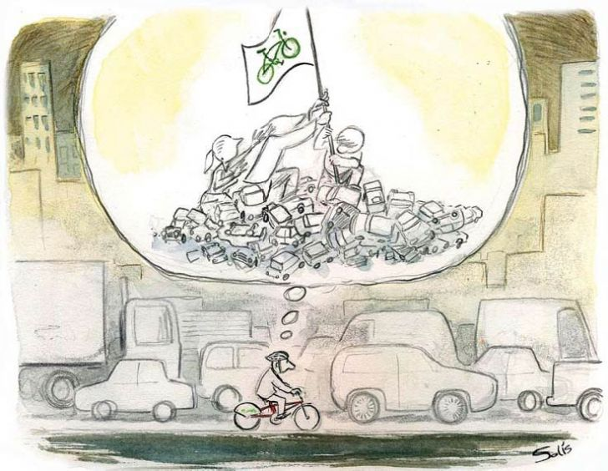

**Cartones**

**Lucie Pelikánová**

*Cartones* are a basis of Mexican political satire and I would like to present five of them that I found the most interesting. All the cartoons come from La Jornada.

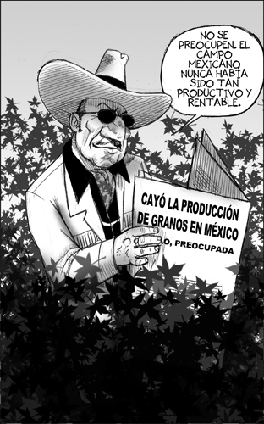The first cartoon is called “*Cultivos más rentábles*”. We could translate it to English “More rentable plants” and what is the point? The person featured in the picture is a typical example of a Mexican “narcotraficante”. In the bubble we can read a text: “Do not worry, the Mexican fields have never been so rentable”. There is no doubt about what kind of plant surrounds him. The author probably wanted to express the situation in Mexico – the agriculture is in trouble, there is less and less arable soil and the agricultural production is decreasing because of many factors. One of them are cheap imports from the United States where governmental subsidies to agricultural sector are huge.

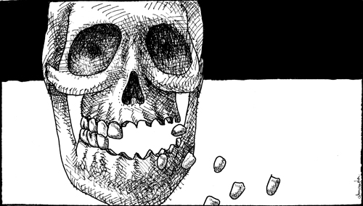

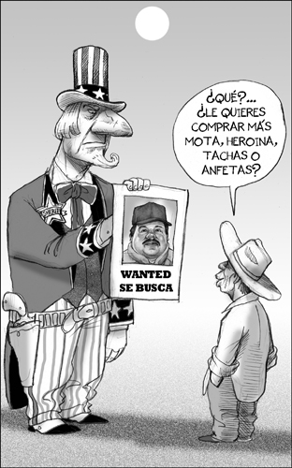

The second cartoon is called: “*Mexico sin granos*” or Mexico without cranes. It has a linkage to the previous one – it is also a criticism of the state of Mexican agriculture and the fact that the production is lowering. The economy of Mexico has ever been dependent on agriculture and cranes exports were an important part of it. The skull without teeth shall present the situation when Mexico is weakened without agriculture production.

This cartoon was named “*Desperadamente buscando al capo*” which can be translated like desperate looking for a boss. This cartoon has many symbols. The man “wanted” in the picture is Chapo Guzman. Since 2003 he has become Mexico’s first narcotraficante after the arrest of Osiel Cardenas from the Gulf Cartel. Since 2009 he has been ranked by Forbes as one of the most powerful people in the World.

After the death of Osama bin Laden in May 2011 he became the FBI and Interpol’s most wanted person. He is nicknamed as a godfather of the drug world, his name el Chapo means “the Shorty” in English. Chapo Guzman is a head of Sinaloa Cartel and he is the only really powerful Narco who have not been arrested.

What shall the picture symbolize? The huge man is a symbol of the Unites States with the typical stripes and stars. And the great Uncle Sam has to go to a little Mexican farmer if he is in trouble and if he needs to find el Chapo. The little person shall symbolize a typical Mexican *campesino*. In the end only these people really know where the bosses are and unfortunately often the campesinos are loyal to the Narcos. The reasons are obvious – the Narco can give them a job, money and some kind of security.

In the picture Uncle Sam asks the campesino where el Chapo is and the little Mexican derides him: “Why? You want to buy more marijuana, heroin…?” Finally the little campesino is more powerful than the United States.

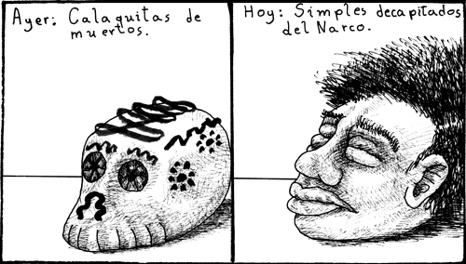

This cartoon was called “Continua la vida”. Yesterday – *calaquitas* of the dead and now the heads of the beheaded victims of the Narcos. The calaquita is a symbol of el Día de los Muertos. It is one of the most important traditions in Mexico. Unfortunately today there are so many victims of the organized crime that the heads are also becoming a symbol.

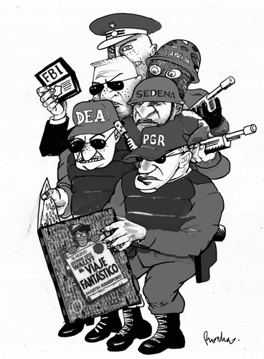

My last cartoon is in my opinion the funniest one. The name “*Buscando el Chapo”* is also about looking for Chapo Guzman. What are the agencies? Attorney General of Mexico, Drug Enforcement Association, Sedena which is the Ministry of Defense in Mexico, FBI… All the agencies cooperate unsuccessfully to find el Chapo. But what is the book they are looking at? It is a very popular American game for little children “Where’s Wally?” The point is - do the agencies really do their best to find him? Is it not only a play to show the politicians and the electorate some will? And in reality it seems very often that there is no real effort to finish it.

**Source**

La Jornada, 4th – 5th November 2011.

1. http://www.justice.gov/dea/pubs/pressrel/pr120611.html retrieved 17.12. 2011., http://www.nytimes.com/2011/12/04/world/americas/us-drug-agents-launder-profits-of-mexican-cartels.html?_r=3&pagewanted=all. retrieved 11.12.2011.
2. http://eleconomista.com.mx/cartones retrieved 10.12.2011.
3. http://eleconomista.com.mx/cartones retrieved 10.12.2011.
4. http://www.elfinanciero.com.mx/index.php/cartones/52195 retrieved 10.12.2011.

   http://eleconomista.com.mx/industrias/2011/12/08/arreciara-competencia-entre-china-otros-proveedores-mexico retrieved 10.12.2011.

   http://www.loc.gov/lawweb/servlet/lloc_news?disp3_l205402892_text retrieved 10.12.2011.
5. Justice in Mexico Project [online]. November 29, 2011 [cit. 2011-12-19]. Petition filed at International Criminal Court against Calderón, El Chapo. Retrieved from WWW: <http://justiceinmexico.org/2011/11/29/petition-filed-at-international-criminal-court-against-calderon-el-chapo/>.
6. La Jornada [online]. December 01, 2011 [cit. 2011-12-19]. El despropósito de Lagarde. Retrieved from WWW: <http://www.jornada.unam.mx/2011/12/01/edito>.
7. Ibid.
8. There are, for example, rumours suggesting that the public debt of the state was 4 times bigger than what was officially admitted.
9. The state treasurer is believed to have been falsifying documents that allowed the government to get more loans.
10. [The video showing Mr Nieto struggling with the question](http://www.youtube.com/watch?v=loC8jFKlMdQ) has become a bit of an internet hit.