**Alternative Investment Funds - Private Equity Investments**

**Descriptive Characteristics**

**and**

**Market Segments**

**Anotace**

Trh alternativních investic je v České republice nehomogenní a nelze jednoduše definovat všechny významné účastníky trhu. Tato situace značně ztěžuje kvantitativní výzkum v oblasti alternativních investic, ať už jsou umístěny do fondů či jiných finančních struktur. Náš výzkum si klade za cíl tuto situaci změnit a přinést mimo jiné detailní klasifikaci účastníků trhu, včetně jejich definování a zajištění statistických údajů.

Od jiných autorů se lišíme multidisciplinárním přístupem k tématu, který kombinuje zkoumání ekonomických a právních aspektů trhu alternativních investic a investičních fondů. Na rozdíl od stávající literatury nám tento přístup umožňuje získat přesnější údaje o účastnících trhu alternativních investičních fondů. Stávající ryze ekonomické studie v oblasti alternativních investic nikterak nerozlišují právní formu investora v oblasti private equity nebo venture kapitálu, což vede k použití nekompletních a nepřesných dat a významného rizika nepřesných závěrů stávajících výzkumů. Naopak ryze právní studie mnohdy velmi přesně a detailně popisují různé právní formy investorů, a to jak teritoriálně, tak v čase, nicméně závěry těchto studií nejsou nijak empiricky ověřeny. V rámci našeho výzkumu spojujeme oba tyto přístupy, kdy bude součástí výzkumného projektu přesné zmapování aktérů trhu, včetně právních forem, a vytvoření jedinečných statistických dat pro Českou republiku. Tato data budou použita pro empirický ekonomický výzkum a vytvoření případové studie pro Českou republiku, jejíž struktura finančního trhu v oblasti private equity se významně liší od většiny evropských trhů. V rámci projektu tak bude detailně zmapován trh investičních fondů a budou definováni všichni aktéři tohoto trhu, čímž se tento projekt liší od jiných autorů.

**Klíčová slova:** alternativní investice, investiční fondy, private equity, venture kapitál, rozvoj podniků, corporate governance, investiční společnosti

**Anotation**

The market for alternative investments in the Czech Republic is heterogeneous and it is difficult to identify all of its participants. Such situation makes the quantitative research in the area of alternative investments very difficult. Aim of our research is, among others, to change this situation and come out with a detailed classification of the market’s participants, including their definition and provision of statistical data.

From other authors we differ by multidisciplinary approach to the topic, which combines investigating the economic and legal aspects of the market for alternative investments and investment funds. Unlike the current research, this approach allows us to obtain more precise data relating to the market of alternative investment funds. Purely economic studies in this field do not distinguish the legal form of the investor which leads to the use of incomplete and inaccurate data, and a significant risk of inaccurate findings of existing research. On the other hand, purely legal studies often very precisely and in detail describe the different legal forms of investors, both territorially and in time, however, the conclusions of these studies are not empirically verified. In our research we combine these two approaches, when part of a research project is a precise mapping of market players, including legal forms, and creation unique statistical data for the Czech Republic. This data will be used for empirical economic research and a potential case study for the Czech Republic where structure of the financial market in private equity is significantly different from most of the European markets. Within the project market of the mutual funds will be mapped in details well as all participants of this market.

**Key words**: alternative investment, investment fund, private equity, venture capital, business development, corporate governance, management company

*Introduction*

Current literature is consistent and emphasizes in consensus that collective investment in the form of investment funds represents necessary and important element of the financial market, no matter the geopolitical arrangement and level of development of a particular country. This method of financing provides risk spreading for investors, and source of financing for projects and companies which are not able to be financed through the public markets[1].

Private equity is commonly defined as a form of investment into private companies not listed on the stock exchange. It is medium to long-term investment, characterized by active ownership. Private equity includes buy-outs and buy-ins, seed-capital investments, start-ups investments, last two are collectively referred as venture capital investments.

In general, most important investors in private equity area are usually banks, pension funds, insurance companies, funds of funds and government agencies. This is true for the European private equity market. According to statistics provided by EVCA, 37.2% of amount raised during the year 2013 is accounted for pension funds, 10.7% was raised by insurance companies, 11.7% by funds of funds.

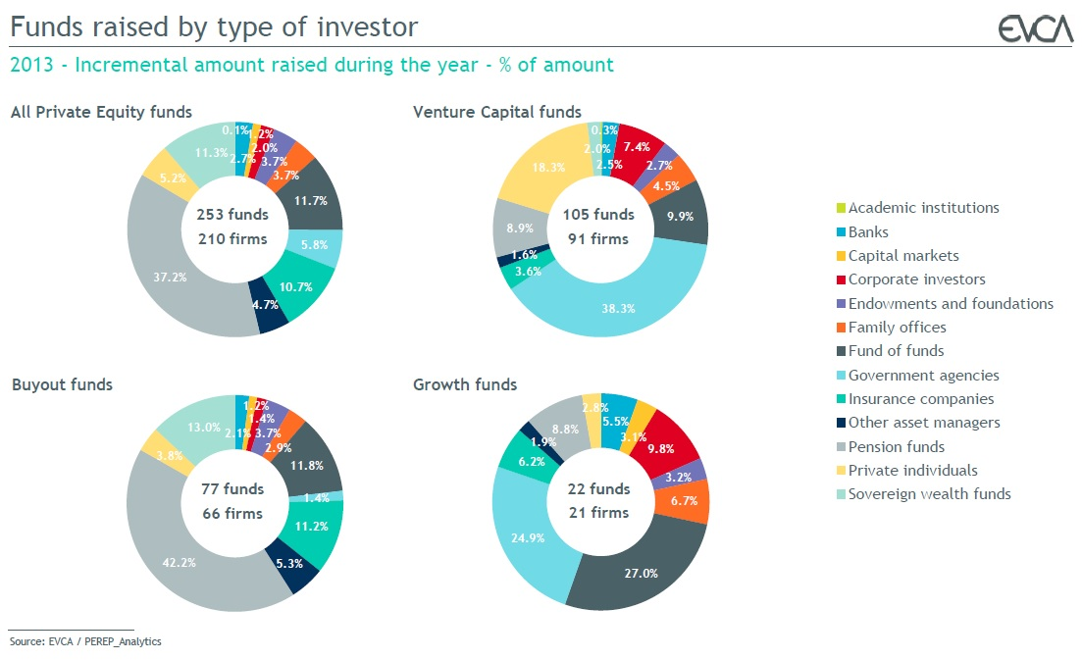

On the other hand, this statistics is not valid for the Czech Republic - there were 54.5% of funds raised by government agencies, 29.1% by corporate investors and 14.6% by banks[2], which creates extremely different private equity market in comparison with European private equity market in general.

*Geographic breakdown*

To understand the private equity market structure and its basic characteristics, it is important to understand who the main market players are. When speaking about the Czech Republic private equity market we include:

* Private equity investors located in the Czech Republic and investing both in companies seated and operating in the Czech Republic and abroad.
* Private equity investors located abroad and investing in companies seated in the Czech Republic.
* Private equity investors located both in the Czech Republic and abroad if they can be offered in the Czech Republic and their management company is located in the Czech Republic.

Speaking of fund-raising as well as investments, private equity firms do not operate only locally, thus the private equity market is internationally connected by both cross-border investments and fund-raising.

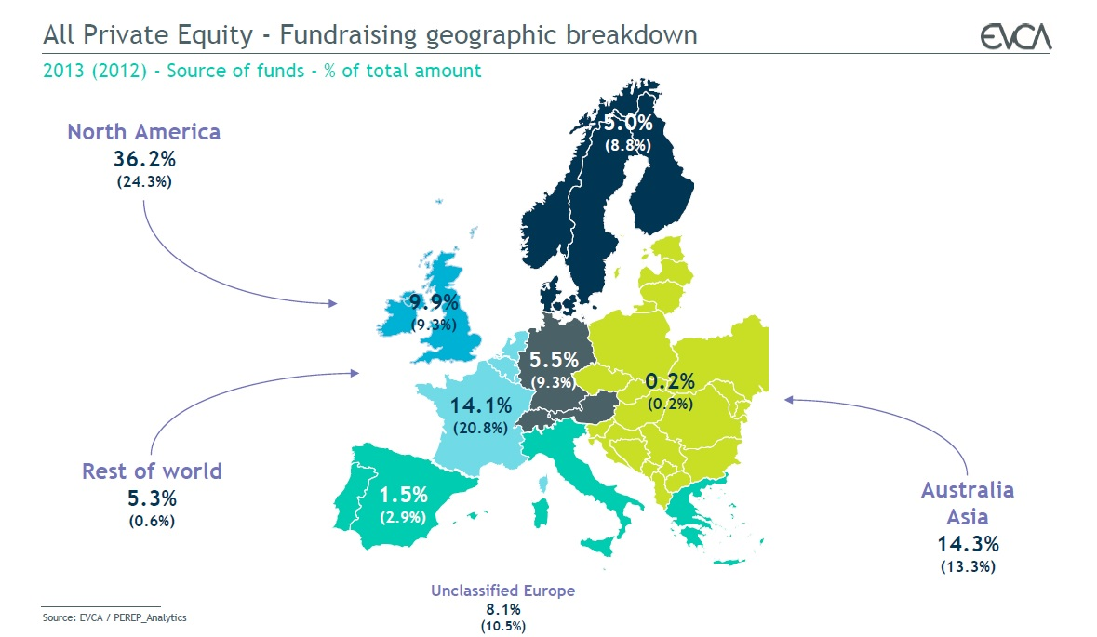

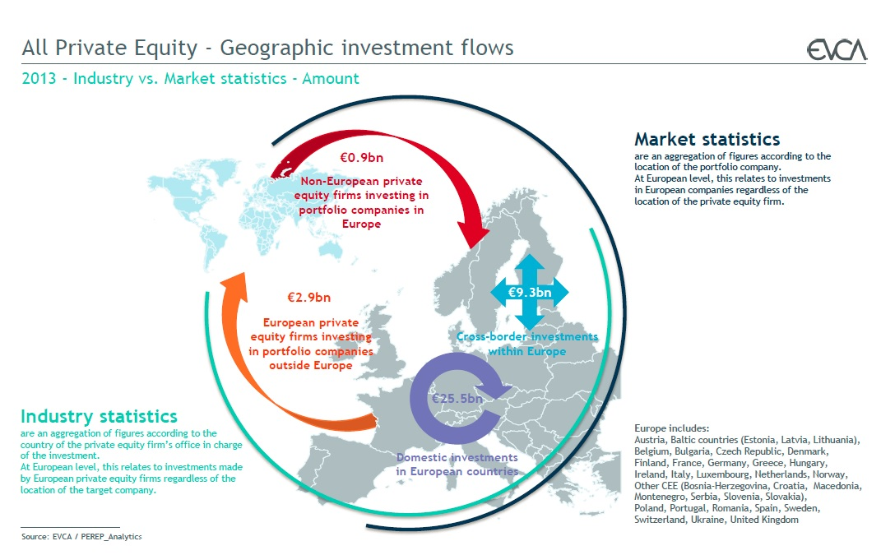

*Investee companies and targets*

In general, we can say that private equity funds operating in the Czech Republic typically realize investments over EUR 1 million. This means that companies in their early stage virtually do not have possibility of this form of financing. There is lack of funds whose investment criterion would involve a small investment of EUR 1 million; neither the network of business angels can substitute this lack.

On the other hand, on the European level, private equity is one of the crucial sources of external financing for the small and medium companies. It is natural that small and medium companies form the absolute majority of investee companies among venture capital investments. But the same is true for the investors focusing on buy-outs and growth of companies.

**Table 1**: *Private equity investments in small and medium companies in Europe*

|  |  |  |
| --- | --- | --- |
| **Type of investment** | **% of amount invested** | **% of number of investee companies** |
| **Venture capital** | 98% | 99% |
| **Buy-outs** | 14% | 52% |
| **Growth** | 55% | 84% |

Source: EVCA statistics, author

*Private Equity Market in the Czech Republic*

To analyze Czech private equity market, we first need to understand its structure. Each type of the market player faces different legislature, different reporting obligation and is subject to supervision of different supervisory body, if any.

We have identified following market players:

1. Investment funds
2. Government agencies
3. Funds of funds
4. Corporate investors
5. Other asset managers
6. Banks
7. Family offices & Private individuals

The list includes very heterogeneous group of players and based on their extremely different characteristics we will examine each group separately to get the relevant and complete data of the Czech private equity market.

As we already mentioned, pension funds and insurance companies as well as investment funds of collective investments are limited by law in the possible asset structure, therefore, in the Czech Republic, they are not assume to be significant participants of the private equity market.

First in our research, we will focus on the investment funds.

*Investment funds*

Investment fund means an entity that collects funds from corporations and individuals for their investment. This entity may have many legal forms, depending on the rules by which it is based (Czech Republic, other EU countries outside the EU), from whom the funds collected (public or qualified investor) and how these funds is funding (equity funds, real estate funds, venture capital). All these factors significantly influence what specific form the investment fund should has and in what jurisdiction is based, and therefore which regulator is responsible for its supervision and also what data the fund is obliged to publish.

Within the Czech legislation it is necessary to distinguish between investment funds of collective investment and investment funds of qualified investors. Collective investment funds collect funds from the public and pursuant to Act no. 240/2012 Coll., on Investment Companies and Investment Funds (the "ZISIV") have a very limited range of assets in which they can invest, especially because of the limitations of risk of assets and maintaining the high level of liquidity. All this is just due to the fact that investors of these funds may be the general public. In contrast to the funds of qualified investors, only so-called "Qualified investors" can invest into the funds for qualified investors. Qualified investors are defined by law ZISIV as a) institutional investors (banks, insurance companies, etc.) Or b) persons who themselves declare that they are qualified investors and their minimum investment amounts is at least 125 000 EUR. The structure of assets of these funds is limited only by basic requirements for diversification of assets stated by ZISIV Act. The assets in which the Funds invest are limited only by the Statute of the Fund itself.

***Table 1*** *– Number of investment funds registered by Czech National Bank*

|  |  |  |  |  |  |  |
| --- | --- | --- | --- | --- | --- | --- |
|  | **31.12.2009** | **31.12.2010** | **31.12.2011** | **31.12.2012** | **31.12.2013** | **31.10.2014** |
| Investment funds with legal personality | 25 | 47 | 58 | 77 | 88 | 84 |
| Investment funds – Unit Trust  (Podílový fond) | 141 | 150 | 157 | 165 | 176 | 196 |
| Foreign investment funds in which investment may be offered in the Czech Republic | 1 450 | 1 315 | 1 214 | 1 157 | 1 165 | 1 253 |

Source: ČNB

***Chart 1*** *– Number of investment funds registered by Czech National Bank*

Zdroj: ČNB

Table and Chart above show the number of investment funds registered with the Czech National Bank. The survey shows that foreign funds in which investment may be offered in the Czech Republic play a very significant role.

Investment funds can also be divided according to whether they have legal personality or not. Funds with legal personality can be further categorized as self-managed or managed by management company. Self-managed fund means a fund that has its own management, which manages the fund, managed investments and assets of the fund and is responsible for its operation and performance of the fund. Non self-governing fund is managed by management company licensed by the market regulator, i.e. Czech National Bank.

*Tax legislation, changes and their impact on the market of the investment funds*

Legislation in the area of investment funds for qualified investors currently develops dramatically, both on national and EU level. Directive 2011/61 / EU (the "AIMFD"), whose requirements are incorporated in the Act “ZISIV”, largely influenced behavior of market participants' investment funds in the European Union, as well as it redefines type of investors which are subject of AIMFD regulation. At the national level, the most visible change is in tax rates for investment funds changed by the amendment to Act No. 586/1992 Coll., On Income Tax (the "ITA"), that is at the time of preparation of this project in approval process and that from 1 January 2015 redefines the term "standard fund", which leads to a new categorization of investment funds, but only for purposes of the tax purposes. Since Directive AIMFD and Act ITA will play an important role in shaping the future investment fund market and market participants’ reacting to legislation changes can be expected already in 2015 and 2016.

Stability of legal environment is important factor of economic development. Since the discussion about the tax changes of investment funds started several years ago and there already were several changes of incorporating the tax changes into the amendments to ITA act, we believe that this one of the factor that highly influences market of investment funds and its development in last few years. Moreover, we expect significant changes as investment funds of qualified investors will react on higher tax rate. Since, there are several options for funds how to tackle the changes, it is important to know the current statistical data as of 31 December 2014 to be able to analyze the macro changes after the tax rate change.

*Description of the Research*

Since we perform research in the area of Czech and European private equity investment funds and funds of qualified investors which are neither properly defined nor examined by current literature, our research consists of several phases.

First goal of the research is to define all market players, their nature, characteristics and regulation, including reporting obligations to be able to state the market’s segments. This is to be done using data from AKAT, EVCA, CVCA and ČNB, all publicly available.

Second step is to compile statistics for each of the market’s segment. As there are data available, we will start with the segment of investment funds for qualified investors. In this part of the research we will examine financial statements of the management companies, investment funds as well as funds’ statutes to get all necessary data.

In third part of our research we will test our hypothesis. We will focus on the following areas:

1. **Corporate governance in investee companies and impact of fee structure for the funds’ managers.**
2. **Sustainability and viability of alternative investment funds in the Czech Republic.**
3. **Taxation and importance of the tax shield; other factprs for investors to invest via regulated investment funds.**

**1. Can fund’s manager fee structure influence level of corporate governance of investee companies?**

*Corporate Governance*

The level of corporate governance is one of the factors that influence the performance of the company and its profitability. The level of corporate governance is, among other things influenced by the principal-agent problem that occurs whenever one entity (the principal) entrusts another entity (agent) for him to carry out certain activities, and in doing so, he entrusts certain powers. Following this definition, the principal-agent problem can be to some extent always present in relation owner-management of company when the company is managed by management and not by the owners. This division of roles may generate benefits for society, particularly with regard to the division of bearing the risk (owners) and taking decisions (management), (Fama and Jensen, 1983). On the other hand, principal-agent problem also causes additional costs and the company reduces its management efficiency and thereby also reduces its profitability (Jensen and Meckling, 1976). However, both methods, contemporary and historical, to increase the level of corporate governance is of its nature always limited (Walsh and Sweard, 1990). Principal-agent problem can be effectively reduced if the owner / investor company actively monitors management.

Current literature agrees that institutional investors can act as an active investor, which effectively minimizes the principal-agent problem. Institutional investors have adequate personnel and expertise for such monitoring. Current research, however, does not agree in the motivation of this monitoring by institutional investors. At present, there was no empirical research conducted that could confirm any of the streams of opinion.

*Fee Structure*

As mentioned above, investment funds can be self-managed or managed by management companies. Regardless the way of their management (own management or management company) fund managers may be rewarded in different ways. Frequently two different methods are used:

* Remuneration for management and administration is calculated as a percentage of assets under management; This percentage is usually fixed for intervals of value of asset under management, with an upper limit;
* Remuneration for the management and administration of assets is calculated as a fixed percentage of the profits of individual assets; there may minimum profit the assets of the fund must achieve in order to reward calculated and paid, so-called “hurdle rate”; rewards are often not set an upper limit for the value of profits from which would reward counted.

Both of these basic methods can be used with different variations, depending on the type of fund, liquidity of its assets and risk of assets.

*Corporate governance of investee company and fee structure*

Current literature agrees that presence of institutional investor, i.e. also investment funds for qualified investors, can assure higher quality of corporate governance of investee company. It is commonly argued that institutional investors possess sufficient experience, know-how and specialists to improve corporate governance of target company. This is expected to be true especially in case of small and middle companies, which are usual subject of private equity institutional investors. However, current literature does not present uniform argument what is the motivation for being an active investor. We argue that fee structure plays crucial role in decision of funds’ managers to behave as active investors or not.

This research can be conducted for all segments of the private equity market no matter the legal form of private equity investors because only the fee structure matters.

***Hypothesis 1: Legal form is not the key factor for the fund performance.***

***Hypothesis 2: Fee structure of the funds’ managers influence costs of corporate governance of investee companies.***

***Hypothesis 3: Performance fee states as percentage from funds’ revenues over stated hurdle rate motivates funds’ managers to become active investors and improves level of corporate governance of investee company.***

**2. Sustainability and viability of alternative investment funds in the Czech Republic.**

We will examine the question of sustainability and viability of alternative investment funds regarding the institutional and legal frame of the Czech Republic and emphasizing the characteristics of the Czech financial market in comparison with the developed markets such as Lichtenstein and the United States of America. Within this area, we would like to compare the development of legislative and institutional conditions with comparable economy to the one of the Czech Republic, namely Malta.

We assume that large proportion of the current investment funds for qualified investors are based only for particular purposes by one or two investors and do not meet the main expected purpose of investment funds, i.e. collective investment. Our assumption is that main reason is the tax shield and possibility of hiding true owners of assets. Such funds will typically have low number of investors as well as investments. Czech legislation requires that each fond of qualified investors must have at least two investors to meet legal criteria of collective investment; and one investment does not have to exceed 35% of funds’ assets.

***Hypothesis: Funds of qualified investors with two investors and less than five investments are subject to special purpose and they should not be classified as participants of investment markets.***

**3. Taxation and importance of the tax shield; other motivators for investors to invest via regulated investment funds.**

This part of the project is highly connected to the previous one. We would like to pay attention to the question of funds' taxation, namely the impact of the potential changes in the tax regime of the investment funds on the long term use and viability of the alternative investment funds in the Czech Republic. A key issue in this regard is how important factor the tax shield is and what are the other motivators for the use of alternative investment funds and how significantly they can replace the advantage of the tax shield in case of negative tax changes. We would like to support our theoretical founding by empirical research on EU economies where changes of the investment funds' tax regime have taken place.

Since there is a change in tax rate as of 1 January 2015 and tax law newly defines “basic investment fund” only for the tax purposes, we expect that management companies will react to this change significantly in 2015, thus, this part of the research can be conducted after such changes will take place, i.e. in 2016, after the funds report their annual reports.

***Hypothesis: Tax legislation stability is a key factor of investment funds activity. This factor is more important than the real tax rate.***

**Abbreviations**

ČNB Czech National Bank

CVCA Czech Private Equity & Venture Capital Association

EVCA European Private Equity & Venture Capital Association

**Literature**

Agarwal V. and Naik N. Y. (2000): *On Taking the ‘Alternative’ Route: risks, Rewards Style and Performance Persistence of Hedge Funds*, Journal of Alternative Investments, Vol. 2, No. 4.

Axelson U., Strömberg P and Weisbach M. S. (2009): *Why are Buyouts Levered? The Financial Structure of Private Equity Funds*, Journal of Finance, Vol. 64, No. 4.

Bethel J., Liebeskind J. and Opler T. (1998): *Block share purchases and corporate performance*, Journal of Finance, Vol. 53, No. 2.

Bradley M. Brav A., Goldstein I. and Jiang W. (2007): *Shareholder activism and price dynamics: Evidence from closed-end funds*, working paper, Duke University, University of Pennsylvania, and Columbia University.

Bratton W. W. (2006): *Hedge funds and governance targets*, Working paper, Georgetown University.

Brav A., Jiang W., Partnoy F. and Thomas R. (2008): *Hedge Fund Activism, Corporate Governance and Firm Performance*, The Journal of Finance, Vol. 63, No. 4.

Brand B. M. (2006): *Monitoring the monitor: Evaluating CalPERS’ shareholder activism*, Journal of Investing, Vol. 16, No. 4.

Carleton W. T., Nelson J. M. and Weisbach S. (1998): *The influence of institutions on corporate governance through private negotiations: Evidence from TIAA-CREF*, Journal of Finance, Vol. 53, No. 4.

Del Guercio D. and Hawkings J. (1999): *The motivation and impact of pension fund activism*, Journal of Financial Economics, Vol. 52.

Del Guercio D., Wallis L. and Woidtke T. (2006): *Do board members pay attention when institutional investors „just vote no“? CEO and director turnover associated with shareholder activism*, Working paper, University of Oregon and University of Tennessee.

Dvořák I. - Procházka P. (1998): *Rizikový a rozvojový kapitál*. 1. vydání. Praha: Management Press, 169 s. ISBN 80-85943-74-3.

Fama E.H. and Jensen M.C. (1983): *Separation of Ownership and Control*, Journal of Law and Economics, Vol. 26, No. 2.

Gillan S. and Starks L. (2000): *Corporate governance proposals and shareholder activism: The role of institutional investors*, Journal of Financial Economics, Vol. 57, No. 2.

Gillan S. and Starks L. (2007): *The evolution of shareholder activism in the United States*, Journal of Applied Corporate Finance, Vol. 19.

Houman B.S. (2009): *The Law and Economics of Hedge Funds: Financial Innovation and Investor Protection*, Berkeley Business Law Journal, Vol. 6, No. 2.

Illig R.C. (2007): *What Hedge Funds Can Teach Corporate America: A Roadmap for Achieving Institutional Investor Oversight*, American Unversity Law Review, Vol. 57, No. 2.

Jensen M.C. and Meckling W.H. (1976): *Theory of the Firm: Managerial Behavior, Agency Cost, and Ownership Structure*, Journal of Financial Economics, Vol. 3.

Kahan M. and Rock E. (2006): *Hedge funds in corporate governance and corporate control*, Working paper, New York University.

Kahn Ch. and Winton A. (1998): *Ownership structure, speculation, and shareholder intervention*, Journal of Finance Vol. 53, No. 1.

Karpoff J. M. (2001): *The impact of shareholder activism on target companies: A survey of empirical findings*, Working paper, University of Washington.

Karpoff J. M., Malatesta P. H. and Walkling R. A. (1996): *Corporate governance and shareholder initiatives: Empirical evidence*, Journal of Financial Economics, Vol. 42, No. 3.

Krikorian B.L. (1991): *Fiduciary Standards: Loyalty, Prudence, voting Proxies, and Corporate Governance*. In A.W. Sametz and J.L. Bicksler (eds.), Institutional Investing: Challanges and Responsibilities of the 21st century (pp. 257-277). Homewood, IL: business One Irwin.

Metrick A. and Yasuda A. (2009): *The Economics of Private Equity Funds*, Review of Financial Studies, Vol. 22, No. 4.

Parthiban D. and Kochhar R. (1996): *Barriers to Effective Corporate Governance by Institutional Investors: Implications for Theory and Practice*, European Management Journal, Vol. 14, No. 5.

Rajchlová J., Baranyková M., Polák M. a Brož Z. (2011): *Podmínky pro využití financování podniků formou private equity a venture kapitálu v České republice a vybraných evropských zemích – identifikace bariér; možnosti řešení*, Trendy ekonomiky a managementu, Vol. 05, No. 9.

Romano R. (2001): Less is more: *Making institutional investor activism a valuable mechanism of corporate governance*, Yale Journal of Regulation, Vol. 18.

Smith M. P. (1996): *Shareholder activism by institutional investors: Evidence from CalPERS*, Journal of Finance, Vol. 51, No. 1.

Wahal S. (1996): *Pension fund activism and firm performance*, Journal of Financial and Quantitative Analysis, Vol. 31, No. 1.

Zinecker M. (2010): *Vliv finanční a ekonomické krize na úroveň private equity a venture kapitálových investic v Evropě*, „Acta Universitatis Bohemiae Meridionales“, Vol. 13., No. 3–4/2010.

Zinecker M. (2011): *Private Equity and Venture Capital: Investment Fund Structures in the Czech Republic*, Acta univ. agric. et silvic. Mendel. Brun., Vol. 59, No. 7.

**Legislation**

*Zákon č. 240/2013 Sb., o investičních společnostech a investičních fondech, ve znění pozdějších předpisů.*

*Zákon č. 189/2004 Sb., o kolektivním investování, ve znění pozdějších předpisů.*

*Zákon č. 586/1992 Sb., o daních z příjmu, ve znění pozdějších předpisů.*

*Directive 2009/65/EC of the European Parliament and of the Council of 13 July 2009 on the coordination of laws, regulations, and administrative provisions relating to undertakings for collective investment in transferable securities (UCITS)*

*Directive 2011/61/EU of the European Parliament and of the Council of 8 June 2011 on Alternative Investment Fund Managers and Amending Directive 2003/41/EC and 2009/65/EC and Regulations (EC) No 1060/2009 and (EU) No 1095/2010 (AIMFD)*

1. Projects and companies which are not suitable to be financed through the public markets especially because of its size or level of development, i.e. level of risk.
2. EVCA statistics